**Project 02_06_01**

In this Project we will build a PHP application to test our knowledge of the unit. Be sure to document all of your code to indicate your understanding.

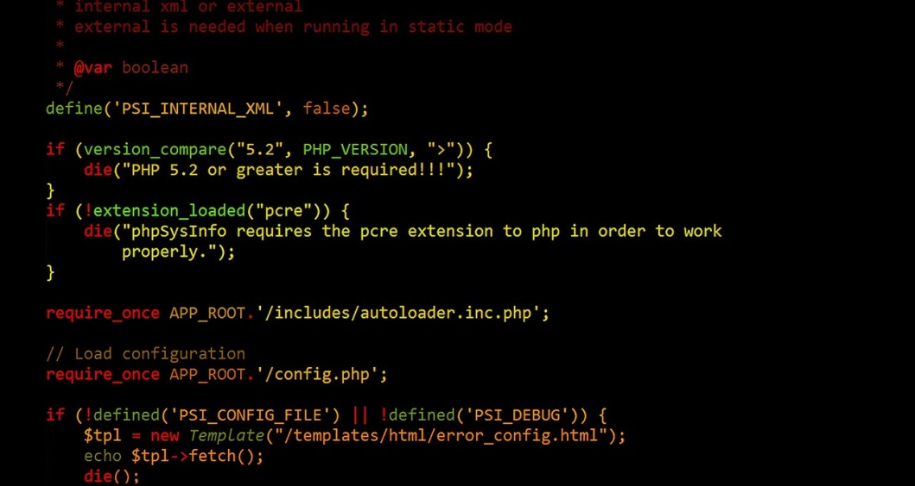 

In this Project, you will create two PHP scripts to create a Guest Book.

Use a PHP script named ***PostGuest.php*** as a Web form that stores visitor names and email addresses in a text file named ***Guests.txt***. The form will need data fields and reset and submit buttons. Make sure that the same user name is prevented from being entered twice. Include a link that allows users to view the guest book (see next script specification). You are expected to provide a form that has a nice appearance, so use some good spacing, and add a little CSS to accomplish that. It will affect the Professionalism and Technique parts of your grade.

Use a PHP script named **GuestBook.php** to display and process the guest book data. You will need to provide a link back to PostGuest.php. You will also need to provide functionality to both ascending and descending sort the guests, delete the first and last guests, and delete any individual guest. Be sure to provide some professional looking output.